Northwind Outdoor Ltd.
High-Level Design
IT Infrastructure Modernisation Project
Redstone Consulting – Jordan Hutchison
9-17-2026

Contents
Northwind Outdoor Ltd. 1
High-Level Design (HLD) 1
IT Infrastructure Modernisation Project 1
Document Control 2
Approval 2
Executive Summary 3
Purpose & Scope 3
Business & Design Context 3
Architecture Principles 4
Proposed Solution Overview 5
Architecture by Domain 13
Key Design Decisions (DD-001 to DD-012) 17
Security Architecture 24
Availability, Backup & Recovery 25
Operational Model 26
Scalability & Future Growth 27
Risks, Assumptions, Constraints & Dependencies 28
Approval & Next Steps 30
Next Steps 30
Outstanding HLD Actions 31

Document Control
Version | Date | Author | Description | Status
V0.1 | 16.09.2026 | Redstone Consulting | Initial High level design draft | Internal Draft
V0.2 | 17.09.2026 | Redstone Consulting | Improved first draft ready for Customer review | Customer Review Draft

Approval
Approval Status: Pending Northwind Approval
Business Approvers | Approval Status
Northwind IT Manager | Approved
Northwind Operations Director | Approved

Executive Summary
Redstone Consulting proposes a modernised, centrally governed, secure, and scalable IT infrastructure for Northwind Outdoor Ltd. This design addresses the organisation’s key business drivers: improving operational efficiency, strengthening security and resilience, and enabling sustainable future growth.
The proposed architecture uses a standardised and centrally managed infrastructure model, with security and operational controls applied consistently across services. Resilience is primarily recovery-led, with redundancy introduced selectively where service criticality and agreed recovery objectives justify the additional complexity and cost.
The architecture establishes standardised infrastructure services, improved identity and access management, structured network segmentation, secure file and data services, robust backup and recovery capabilities, and a controlled operational model. It supports Northwind’s critical business systems while providing a foundation for future expansion, automation, and additional business capabilities.
This HLD defines the solution direction, architectural principles, and domain-level design which is designed to address the requirements established within the approved BRD and associated RTM baseline—without prescribing specific technologies, products, or vendors.

Purpose & Scope
This High-Level Design (HLD):
- Defines the proposed future-state architecture for Northwind’s modernised IT environment.
- Aligns all architectural components with the approved Business Requirements Document (BRD v1.0) and the Requirements Traceability Matrix (RTM).
- Provides customer-facing descriptions of design decisions, architectural principles, and domain-level solution direction.
- Establishes the foundation for subsequent Low-Level Designs (LLDs), Statements of Work (SoWs), implementation planning, and testing.
- Defines what the proposed architecture will provide and the principles governing its design; detailed implementation specifications, configuration parameters and build procedures are deferred to subsequent LLDs and implementation documentation.

In Scope
The HLD addresses the twelve agreed architecture domains covering
Network | Backup & Recovery
Compute & Platform | Security
Identity & Access | Observability
Core Infrastructure Services | Management & Operations
Application & Business Services | Integration
Storage | Resilience & Availability

Detailed Design Boundary
Detailed product selection, host sizing, IP addressing, VLAN configuration, storage allocation, firewall rules, package selection, service configuration and build procedures are outside the scope of this HLD and will be defined through subsequent LLDs, Statements of Work and implementation documentation.

Out of Scope (v1)
- Broad deployment of High Availability clustering and active/active service architectures. Selective redundancy may be introduced where justified by approved service-criticality and recovery requirements.
- Enterprise-scale directory/federated identity platforms beyond the approved v1 identity and access model.
- Advanced automation frameworks.
- Second-site DR architecture (future consideration aligned with Northwind’s 3–5 year growth plan).

Business & Design Context
The architecture is shaped by key drivers, constraints, assumptions, and NFRs documented in the BRD and RTM. The proposed architecture has been developed in response to the business drivers, requirements, constraints, assumptions and non-functional requirements established during discovery and documented within the approved BRD and associated RTM.

Key Drivers
- Operational Efficiency — Improve the consistency, manageability and efficiency of IT operations.
- Security & Resilience — Strengthen protection of business systems and information while improving Northwind's ability to recover from disruption.
- Sustainable Growth — Establish an infrastructure foundation capable of supporting anticipated growth in users, data and business services.

Constraints
- Service Continuity — Disruption to existing business-critical services during migration and implementation shall be minimised, with planned service interruptions subject to agreed change and maintenance arrangements.
- Cost & Resource Proportionality — Available budget, infrastructure capacity and operational resources require resilience measures to be proportionate to business criticality rather than applying HA universally.
- Existing Service Integration — The proposed architecture must remain compatible with required existing business systems and workflows.

Assumptions
- Northwind will provide accurate asset baselines.
- Recovery Objectives — Service-specific RTO and RPO requirements will be confirmed by Northwind before detailed recovery and resilience designs are finalised.
- Northwind will participate in UAT and design reviews.

Important NFRs Shaping the Architecture
- Availability – proportionate resilience.
- Security – defence in depth.
- Recoverability – recovery-led resilience.
- Observability – monitoring and logging.
- Operational Consistency — standardised and repeatable administration to reduce variation and human error.
- Scalability – managed growth.

Architecture Principles
The following architectural principles have been applied consistently when evaluating design options and establishing the proposed solution.
- Standardisation — Use consistent build patterns, configuration standards and operational processes wherever practical to reduce complexity, configuration drift and administrative error.
- Recovery-Led Resilience — Prioritise reliable and tested recovery as the baseline resilience model, introducing redundancy and High Availability where justified by service criticality and recovery objectives.
- Security by Design — Apply defence in depth, least privilege, segmentation and host-level controls throughout the architecture rather than treating security as a separate downstream activity.
- Automation Where Appropriate — Automate stable and repeatable operational activities where doing so reduces administrative effort and human error, while retaining appropriate control, documentation and recoverability.
- Managed Growth — Design infrastructure so that users, data, workloads and services can grow without requiring disproportionate redesign or premature enterprise complexity.
- Controlled Change — Infrastructure changes should be documented, tested where practical, approved where required, verifiable and recoverable.
- Supportability — Infrastructure shall be designed so that Northwind's IT team can operate, maintain and troubleshoot it using appropriate documentation, procedures, monitoring and knowledge transfer.

Proposed Solution Overview
Northwind’s future-state architecture is a centrally governed infrastructure platform providing secure, resilient, and scalable services.
The architecture consolidates Northwind’s core infrastructure and business services onto a standardised virtualised compute platform, supported by segmented network services, controlled identity and administrative access, structured storage, backup and recovery, and central operational visibility. The design adopts recovery-led resilience as its baseline, with additional redundancy introduced selectively where justified by service criticality and agreed recovery objectives.

High-Level Architecture Summary
- Compute & Platform: A standardised virtualised server environment providing compute resources for core infrastructure and supported business services, with separation between production and testing/sandbox workloads.
- Identity & Access: A standardised identity and access model providing named user identities, role-appropriate access, controlled privilege elevation and consistent joiner/mover/leaver administration across supported Linux services.
- Network: A segmented network architecture separating user, server/infrastructure, management/administration and external/untrusted environments, with controlled communication between security zones.
- File/Data: Secure file services providing structured departmental data organisation, controlled access and compatibility with required user workflows.
- Storage: Logically separated persistent storage supporting controlled allocation, capacity expansion and recovery requirements for hosted services and business data.
- Backup/Recovery: Layered backup and recovery capabilities providing automated protection, secondary copies outside the primary failure domain, scheduled restoration testing and documented recovery procedures.
- Security: Defence-in-depth controls incorporating network segmentation, host-level security enforcement, strong authentication, controlled administrative access, patch governance and security-relevant logging and monitoring.
- Observability: Central monitoring and alerting combined with native system diagnostic capabilities, supported by local and selected centralised logging, historical performance information and operational reporting.
- Remote & Administrative Access: Controlled remote access separating ordinary business access from privileged administration, with named identities, strong authentication, controlled privilege elevation and auditable administrative activity.
- Management & Operations: Standardised administration, controlled software and patch lifecycles, documented operational procedures and automation of appropriate repeatable activities.

High-Level Architecture Diagrams

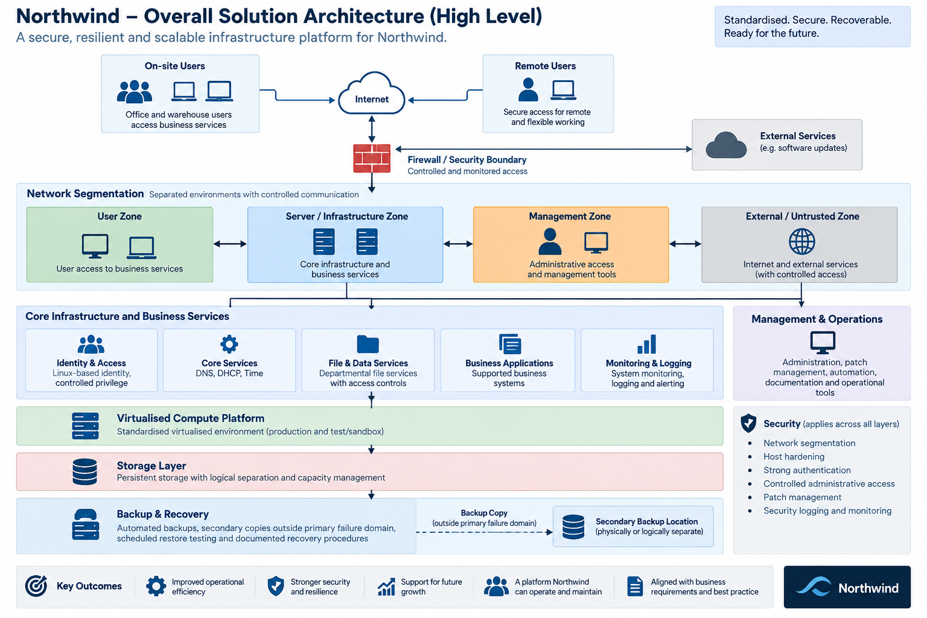
Overall Solution Architecture

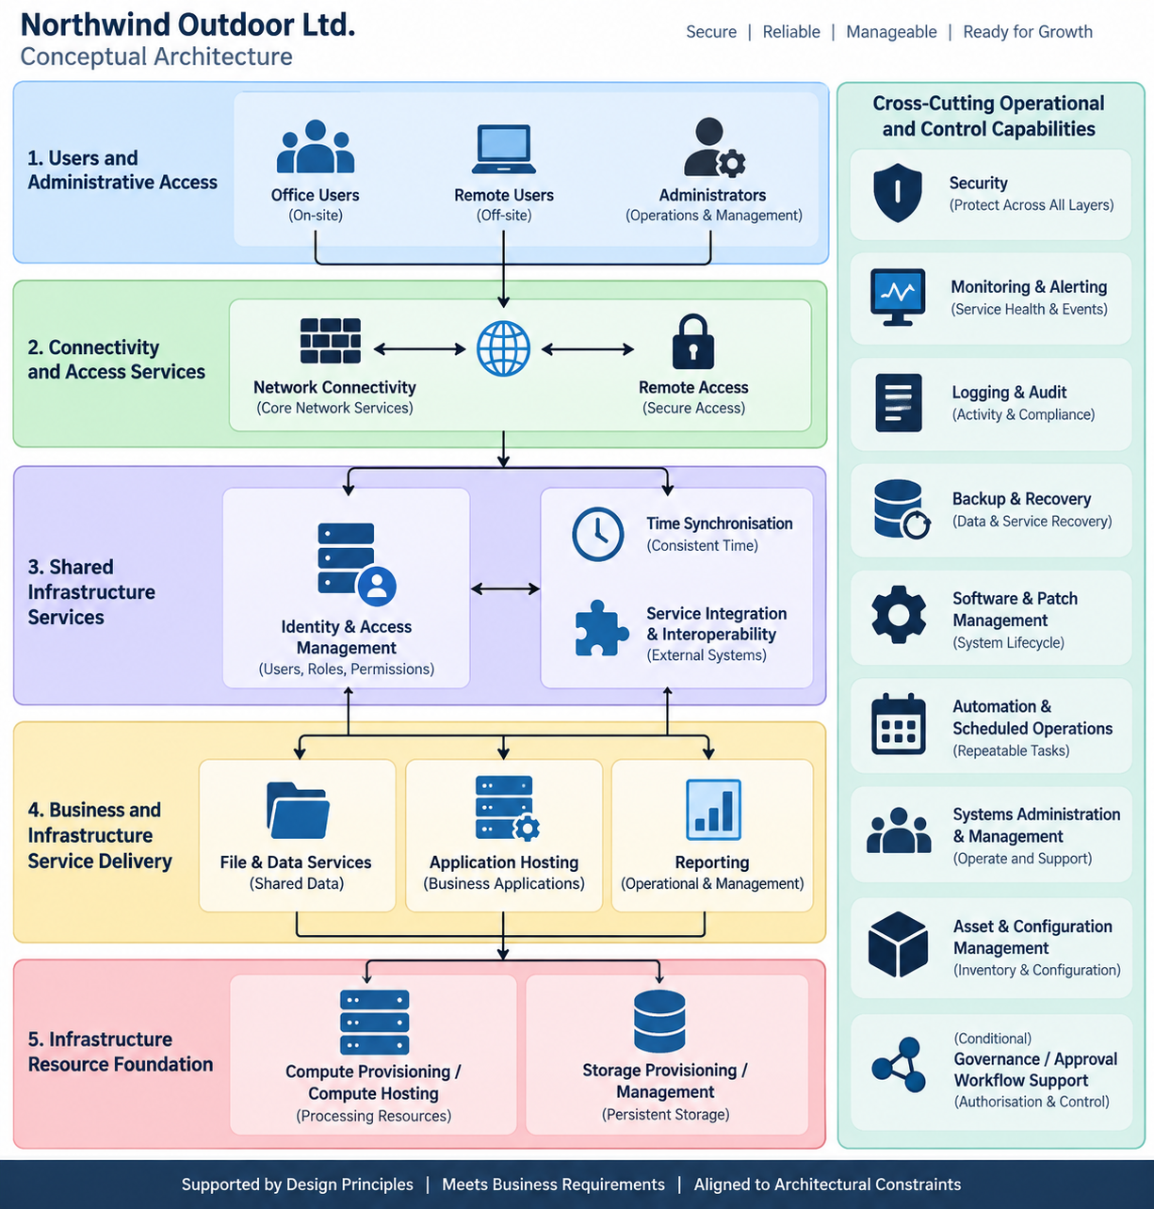
Conceptual Architecture

Network & Access Architecture

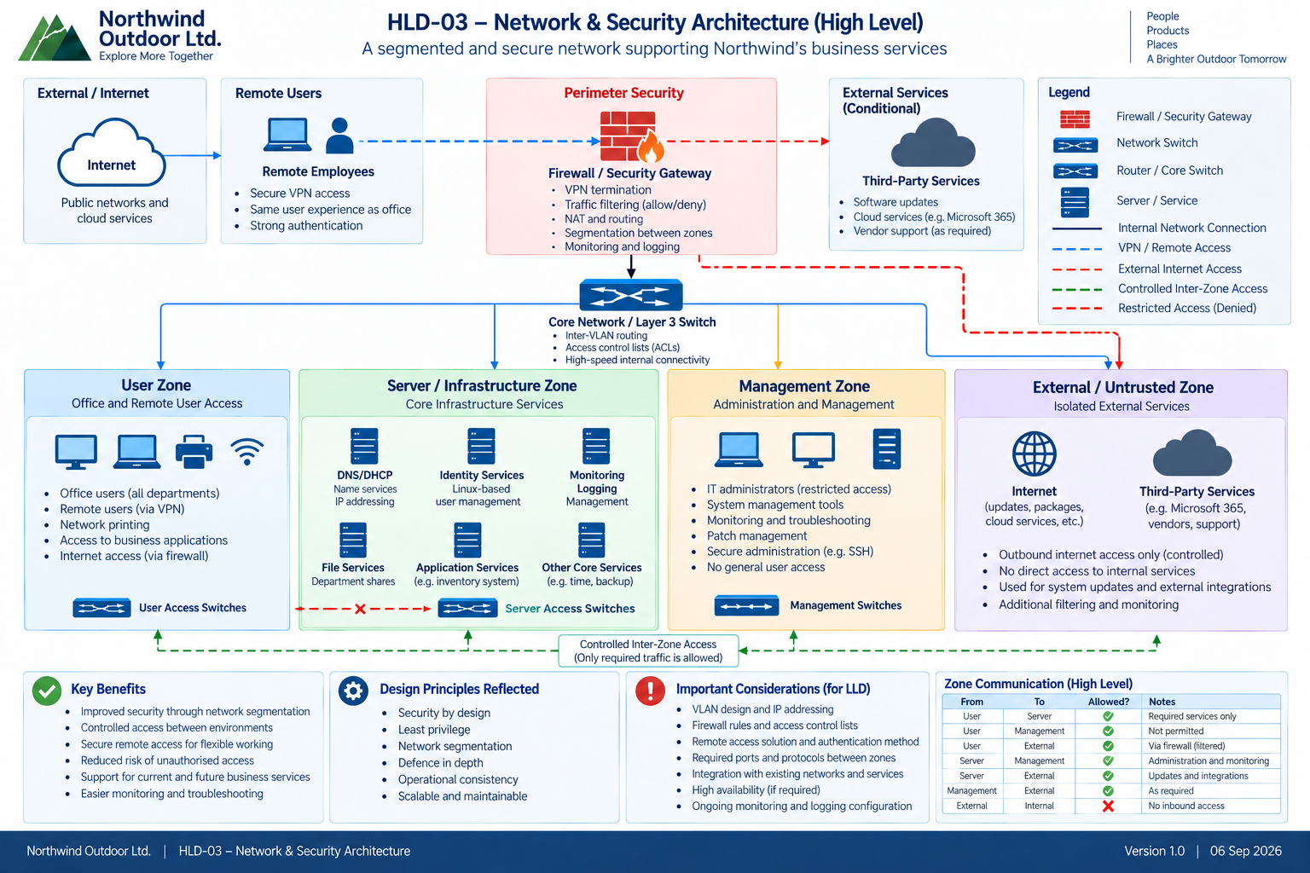

Compute, Storage & Service Infrastructure
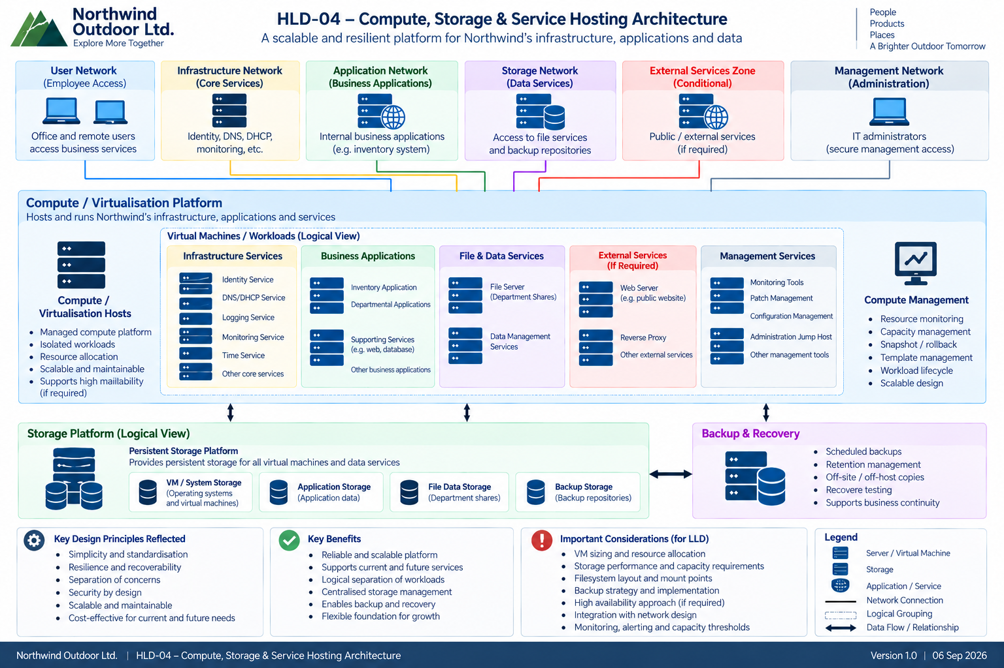

Operations, monitoring & Recovery

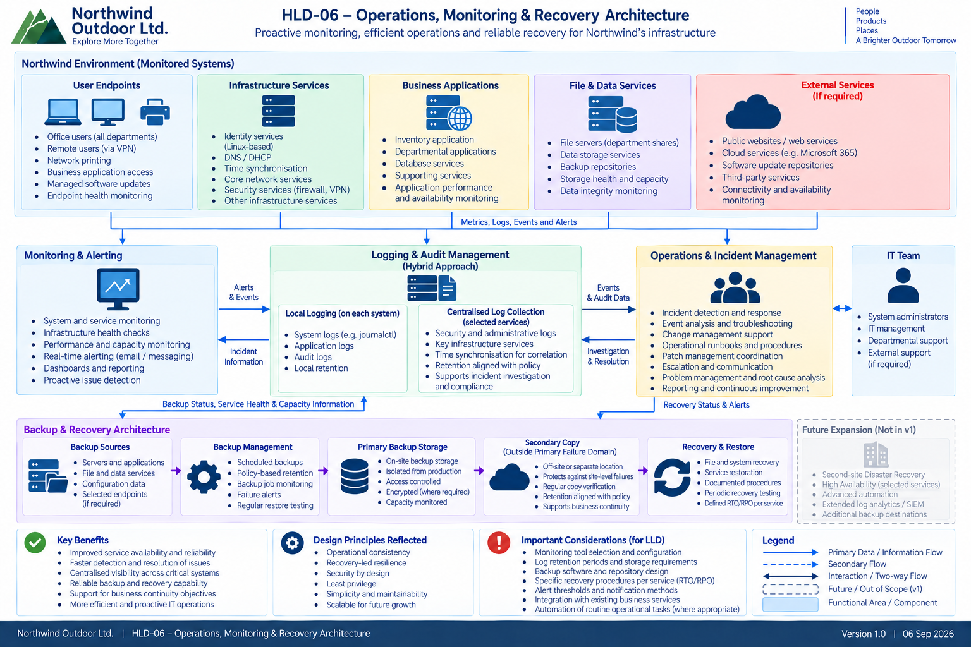

Identity, Security & Administration
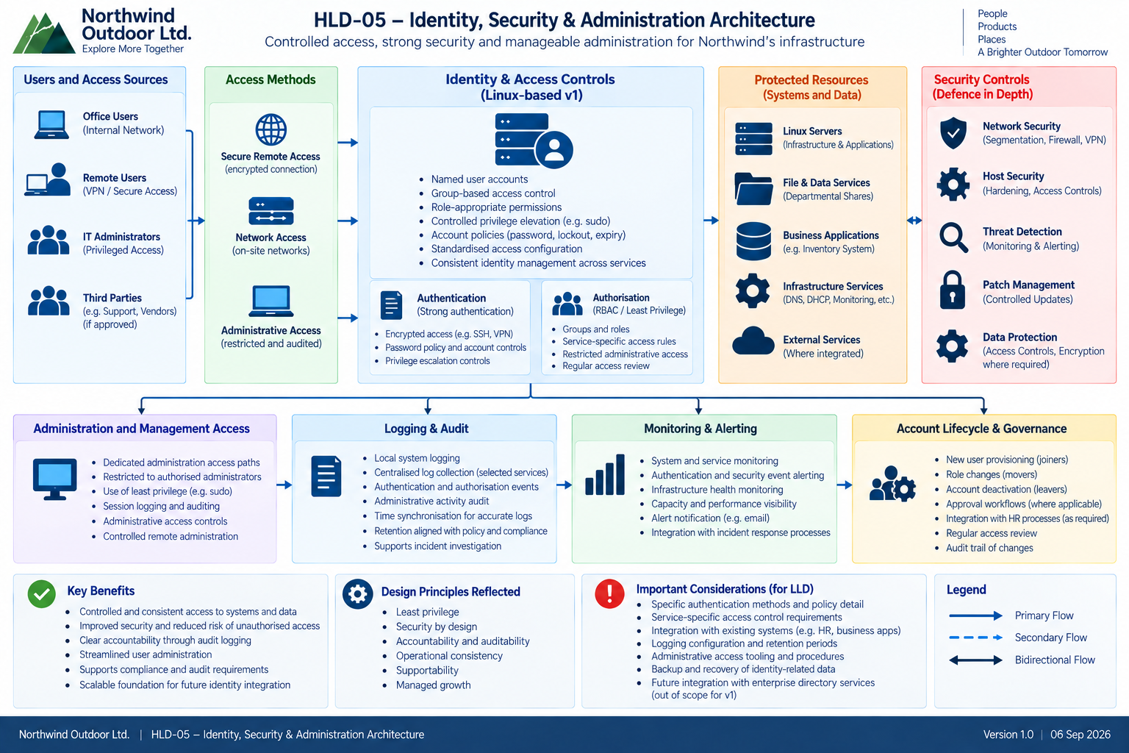

Architecture by Domain

AD-01 Network Architecture
Northwind will adopt a functionally segmented network architecture separating systems according to trust and operational purpose. The network will provide controlled connectivity between users, infrastructure services, administrative systems and external services while limiting unnecessary access between security zones.
- Distinct User, Server/Infrastructure, Management/Administrative and External/Untrusted trust zones.
- Inter-zone communication governed by least-privilege and default-deny principles, permitting only required service flows.
- Secure remote access places remote users and administrators into the appropriate user or administrative trust context.
- Administrative interfaces and management services accessible only through trusted administrative paths.
- Network controls complemented by host-level security and integrated monitoring/logging.
Detailed VLANs, addressing, routing, firewall rules and permitted service-flow matrices will be defined during LLD.

AD-02 Compute & Platform Architecture
Northwind's infrastructure and supported business services will operate on a standardised virtualised compute platform, providing a consistent foundation for workload deployment, administration and future growth.
- Virtualised hosting for supported infrastructure and business-service workloads.
- Standardised Linux operating-system and configuration baselines.
- Logical separation of workloads according to service role and security requirements.
- Sandbox/testing capability supporting validation of changes, updates and administrative procedures before production deployment.
- Compute capacity capable of being expanded as workload requirements grow.
Exact platform configuration, workload placement, VM sizing and resource allocation will be defined during LLD.

AD-03 Identity & Access Architecture
Northwind v1 will use a standardised Linux-native identity and access model providing named user identities, group-based access control and controlled administrative privilege across supported Linux systems.
- Local Linux user and group identities managed according to documented standards.
- Group membership, ownership, permissions and access-control mechanisms used to enforce role-appropriate access.
- Privileged administration performed using named administrator identities and controlled privilege elevation rather than routine direct root access.
- Joiner, mover and leaver activities governed by repeatable procedures across applicable systems.
- Suitable repetitive account-management activities may be automated after the underlying processes have been established and validated.
Centralised enterprise IAM is deferred for v1 and may be reassessed if infrastructure scale, administrative workload, identity drift or security requirements justify it.

AD-04 Core Infrastructure Services
Northwind will provide standardised core infrastructure services required for reliable operation and communication across the supported environment.
- Managed name-resolution services supporting reliable service discovery.
- Controlled network-configuration services for applicable client networks.
- Consistent system time across supported infrastructure to enable reliable authentication, logging, auditing, monitoring and troubleshooting.
- Core-service configuration managed according to documented standards and protected through appropriate security, monitoring and recovery controls.
- Dependencies on core services considered when defining service-recovery procedures.
Exact DNS, DHCP and time-service topology, configuration and upstream dependencies will be defined during LLD.

AD-05 Application & Business Services
Northwind's supported internal business applications and shared services will be hosted within controlled infrastructure environments and made available only to authorised users and systems.
- Internal business applications hosted on the standardised compute platform.
- Secure file and data services providing structured departmental sharing and access.
- Print services provided where required by business workflows.
- Application access restricted according to user, service and network requirements.
- Compatibility and interoperability with required existing Northwind business services preserved.
Application-specific sizing, dependencies, packages, databases, service accounts and configuration will be defined during LLD.

AD-06 Storage Architecture
Northwind v1 will use locally presented Linux storage providing flexible allocation and controlled growth for hosted systems, applications and business data.
- LVM-backed XFS adopted as the baseline persistent-storage architecture.
- Business data logically separated according to capacity, security, recovery and operational requirements.
- Additional filesystems introduced where genuine isolation or recovery requirements justify them rather than automatically creating one filesystem per department.
- Storage capacity and utilisation monitored to support proactive growth planning.
- Independent backup remains mandatory; storage snapshots or point-in-time mechanisms are not treated as substitutes for backup.
Exact volume groups, logical volumes, filesystem sizes, mount points and capacity thresholds will be defined during LLD.

AD-07 Backup & Recovery Architecture
Northwind will adopt a layered backup and recovery architecture designed to protect business data, configuration and supported workloads against operational error, corruption and infrastructure failure.
- Short-term point-in-time recovery mechanisms used where appropriate for rapid operational rollback.
- Dedicated backup service and protected backup storage providing independent recoverability.
- Secondary backup copy maintained outside the primary production failure domain.
- Backup schedules, retention and recovery methods aligned with service-specific RPO/RTO requirements.
- Scheduled restore testing used to demonstrate actual recoverability rather than relying solely on successful backup-job status.
- Documented recovery procedures maintained for supported critical services.
Detailed schedules, retention periods, repositories and recovery procedures will be defined during LLD and operational documentation.

AD-08 Security Architecture
Security will be applied as a cross-cutting architectural concern using defence-in-depth controls across identity, network, host, administrative and operational layers.
- Least-privilege access applied to users, administrators, services and automated activities.
- Network segmentation and controlled inter-zone communication reduce unnecessary trust and lateral movement.
- Linux host-level controls, including host firewalling and mandatory access controls where applicable, complement network security.
- Remote and privileged administrative access restricted to controlled and auditable access paths using strong authentication.
- Security-relevant events incorporated into logging, monitoring and investigation processes.
- Software and system updates governed through controlled testing and deployment processes.

AD-09 Observability Architecture
Northwind will use a hybrid observability model combining central operational visibility with native Linux logging, diagnostic and troubleshooting capabilities.
- Central monitoring and alerting provides continuous visibility into supported host, service and resource health.
- Historical performance and capacity data retained to support trending, reporting and growth decisions.
- Native Linux diagnostic tools retained for detailed host-level investigation and troubleshooting.
- Local system and audit logging retained, with selected security and operational records forwarded centrally where beneficial.
- Consistent time maintained across infrastructure to support reliable event correlation and investigation.
- Alerts routed to appropriate IT personnel when defined warning or critical conditions occur.

AD-10 Management & Operations Architecture
Northwind will operate the environment using documented, repeatable and controlled administrative processes designed to reduce operational variation and support effective troubleshooting and recovery.
- Administrative access restricted to authorised personnel using named identities and controlled privilege.
- Software and patch lifecycle governed through approved sources, sandbox validation, controlled deployment and post-change verification.
- Repeatable and sufficiently understood administrative activities progressively automated using controlled Linux-native mechanisms.
- Automation documented, version-controlled, tested and monitored so failures remain visible and actionable.
- SOPs, runbooks, build documentation and recovery procedures maintained to support Northwind's IT team.
- Asset and configuration information maintained sufficiently to support ownership, lifecycle and operational management.

AD-11 Integration Architecture
The proposed architecture will preserve compatibility with existing Northwind business services and provide controlled mechanisms for required interaction with external or supporting systems.
- Existing business workflows and required service dependencies considered during detailed design.
- Integration traffic subject to the same network, security and access-control principles as other service communications.
- External integrations permitted only where required and appropriately controlled.
- Architecture designed so future integrations can be introduced without fundamental redesign where practical.
Specific interfaces, protocols, authentication mechanisms and service dependencies will be confirmed during LLD.

AD-12 Resilience & Availability Architecture
Northwind v1 will adopt a recovery-based resilience model as the baseline, prioritising rapid detection, reliable recovery and tested rebuild procedures over broad High Availability complexity.
- Single service instances and a single compute platform accepted where business recovery objectives can be met through recovery.
- Monitoring and alerting used to reduce failure-detection time.
- Protected backups, standardised builds and documented recovery procedures provide the primary recovery mechanisms.
- Service criticality and service-specific RTO/RPO requirements determine whether additional resilience is required.
- Selective redundancy may be introduced where recovery alone cannot reasonably satisfy approved availability requirements.
- Broad HA, clustering and replicated infrastructure deferred until justified by business requirements.
- Recovery procedures periodically tested and measured against agreed objectives.

Key Design Decisions (DD-001 to DD-012)
The following decisions define the principal architectural direction proposed for Northwind v1. They represent the outcome of requirements analysis, capability modelling, architectural evaluation and consideration of relevant constraints and non-functional requirements.
Detailed option analysis and design rationale are maintained within Redstone's Design Decision Register; this HLD presents the selected architectural direction and the principal implications requiring customer review and approval.
Approval of this HLD confirms Northwind's acceptance of the proposed high-level architectural direction and key design decisions. Detailed technical implementation remains subject to subsequent LLD, implementation planning and applicable change approval.

DD-001 — Compute / Virtualisation
Decision
Northwind will use a standardised virtualised compute platform as the primary hosting foundation for supported infrastructure services and business applications.
Rationale
Virtualisation provides workload isolation, consistent provisioning and flexible resource allocation while allowing Northwind to consolidate services onto a manageable infrastructure platform. It also provides a scalable foundation on which additional services can be introduced without requiring dedicated physical infrastructure for each workload.
Key implications
- Infrastructure and supported applications will generally be deployed as logically separated virtual workloads.
- Common build and operating-system standards will reduce configuration variation.
- Compute resources can be adjusted as workload requirements change.
- Sandbox/test workloads can be separated from production services.
- Platform capacity will require ongoing monitoring as Northwind grows.
Detailed Design
Host configuration, workload placement, VM sizing, resource allocation and platform-specific implementation will be defined during LLD.

DD-002 — Identity & Access Management Architecture
Decision
Northwind v1 will use a standardised Linux-native identity and access model, based on named user identities, group-based access controls, documented account-management standards and controlled administrative privilege.
Rationale
This approach satisfies the immediate access-control and user-management requirements of the v1 Linux environment without introducing an enterprise identity platform whose complexity would be disproportionate to the current infrastructure scale.
Key implications
- Linux users and groups provide the baseline identity model.
- Role-appropriate access is implemented through group membership, ownership and permissions.
- Administrators use named accounts and controlled privilege elevation rather than routine direct root access.
- Joiner, mover and leaver processes must be documented and consistently applied.
- Suitable repeatable account-management activities may later be automated.
- Centralised enterprise IAM remains a future option if scale or operational requirements justify it.
Detailed Design
Account standards, groups, privilege configuration, password/authentication controls and lifecycle procedures will be defined during LLD.

DD-003 — File & Data Services Architecture
Decision
Northwind will provide consolidated Linux-based file and data services supporting structured departmental data, controlled access and compatibility with required user workflows.
Rationale
Consolidated file services provide a more consistent and manageable alternative to fragmented data storage while enabling Northwind to apply common access, organisation, backup and recovery controls.
Key implications
- Departmental business data will be organised through defined shared structures.
- Access will be controlled through the approved identity/access model.
- Required Linux and Windows user workflows will be supported through appropriate interoperable file-access mechanisms.
- Business data will reside on persistent managed storage and be protected through the backup architecture.
- Data segregation will follow genuine security and operational requirements.
Detailed Design
Share structures, access protocols, permissions, quotas and detailed filesystem arrangements will be defined during LLD.

DD-004 — Storage Architecture
Decision
Northwind v1 will use locally presented LVM-backed XFS storage as the baseline persistent-storage architecture.
Rationale
This provides a mature Linux-native storage model supporting flexible allocation, capacity expansion and manageable filesystem administration without introducing a dedicated enterprise storage tier before one is required.
Key implications
- LVM provides logical capacity management and controlled expansion.
- XFS provides the standard persistent filesystem baseline.
- Business/application data can be logically separated where capacity, security or recovery requirements justify it.
- Capacity utilisation will be monitored and reviewed.
- Storage snapshots or point-in-time mechanisms do not replace independent backup.
- Dedicated network/shared storage may be considered in later phases if scale or resilience requirements justify it.
Detailed Design
Physical volumes, volume groups, logical volumes, filesystem sizes, mount points and expansion procedures will be defined during LLD.

DD-005 — Backup & Recovery Architecture
Decision
Northwind will adopt a layered backup and recovery architecture combining appropriate short-term recovery mechanisms, protected backup storage and a secondary copy outside the primary production failure domain.
Rationale
No single recovery mechanism adequately protects against operational error, data corruption, infrastructure failure and loss of the primary environment. Layered protection provides proportionate recovery options while reducing reliance on any single system or storage location.
Key implications
- Supported systems and business data will be backed up according to defined schedules and retention requirements.
- Backup storage will remain logically protected from normal production access.
- A secondary copy will exist outside the primary failure domain.
- Successful backup jobs alone will not be considered evidence of recoverability.
- Restoration testing will be performed periodically.
- Recovery procedures will be documented.
- Service-specific RTO/RPO requirements will influence detailed backup and recovery design.
Detailed Design
Backup tooling, schedules, repositories, retention periods, encryption requirements and restore procedures will be defined during LLD.

DD-006 — Monitoring & Alerting Architecture
Decision
Northwind will use a hybrid monitoring model combining central operational monitoring and alerting with native Linux diagnostic and troubleshooting capabilities.
Rationale
Central monitoring provides visibility across the environment and enables proactive detection of failures and resource constraints, while native operating-system tools retain the detailed diagnostic capability required for effective technical investigation.
Key implications
- Supported systems and services will expose appropriate health and resource information.
- Central monitoring will provide service status, alerting and historical performance/capacity information.
- Defined warning and critical conditions will generate actionable alerts.
- Native Linux tools remain the primary detailed troubleshooting layer.
- Monitoring information will support capacity planning, incident response and operational reporting.
Detailed Design
Monitoring tooling, monitored items, thresholds, notification channels, retention and escalation rules will be defined during LLD.

DD-007 — Logging & Audit Architecture
Decision
Northwind will use a hybrid logging and audit architecture, retaining authoritative local Linux logging and audit records while forwarding selected operational and security information centrally where this improves visibility, correlation or investigation.
Rationale
Local logging preserves detailed system-level evidence and supports troubleshooting even if central services are unavailable, while selective central collection improves cross-system investigation and operational visibility without requiring unnecessary collection of every available record.
Key implications
- Supported systems retain appropriate local logs and audit records.
- Selected security, administrative and infrastructure events may be collected centrally.
- Retention will reflect operational, investigation and policy requirements.
- System time must remain sufficiently consistent to support reliable event correlation.
- Logging information will support troubleshooting, accountability and security investigation.
- Significant events may integrate with monitoring and alerting.
Detailed Design
Log sources, audit rules, forwarding criteria, central retention, storage requirements and time-synchronisation configuration will be defined during LLD.

DD-008 — Remote & Administrative Access Architecture
Decision
Northwind will provide controlled remote and administrative access, clearly separating ordinary remote business access from privileged infrastructure administration.
Rationale
Remote working and infrastructure administration create different levels of risk and therefore should not share unrestricted access paths. Separating the two allows Northwind to support flexible working while applying stronger controls to privileged administration.
Key implications
- Remote employees receive access only to authorised business services.
- Privileged infrastructure administration is restricted to trusted administrative paths.
- Administrative actions use named identities and controlled privilege elevation.
- Strong authentication is applied appropriate to the access path.
- Direct routine root administration is prohibited.
- Administrative activity is logged and auditable.
- Controlled recovery access will remain available for appropriate failure scenarios.
Detailed Design
Remote-access technology, authentication mechanisms, administrative protocols, access restrictions and recovery-access procedures will be defined during LLD.

DD-009 — Network Security & Segmentation Architecture
Decision
Northwind will use functional network segmentation with controlled inter-zone communication, separating User, Server/Infrastructure, Management/Administrative and External/Untrusted trust zones.
Rationale
Segmentation limits unnecessary communication between systems with different trust and operational requirements, reduces exposure and lateral movement, and creates clearer security boundaries without introducing excessive network complexity.
Key implications
- Inter-zone access follows a default-deny, explicitly permitted model.
- User systems access only required infrastructure and business services.
- Administrative systems and interfaces are restricted to the Management/Administrative trust zone and approved access paths.
- External/untrusted connectivity is tightly controlled.
- Network controls are complemented by Linux host firewalls and host security enforcement.
- Unsolicited inbound Internet access is not part of the v1 baseline.
- Additional segmentation can be introduced later where justified.
Detailed Design
VLANs, IP addressing, routing, firewall policy, service-flow matrices and individual access rules will be defined during LLD.

DD-010 — Patch & Software Lifecycle Management Architecture
Decision
Northwind will use a controlled Linux-native software and patch lifecycle, based on approved software sources, standard role baselines, sandbox validation, controlled production deployment and post-change verification.
Rationale
Software updates are necessary for security and supportability but can themselves introduce operational risk. A controlled lifecycle balances timely maintenance with testing, approval and recoverability.
Key implications
- Software will be obtained from approved repositories and sources.
- Systems will follow defined software/package baselines according to role.
- Significant updates will be validated in the sandbox before production deployment where practical.
- Updates will follow an agreed cadence and approval process.
- Production changes will be verified after deployment.
- Recovery or rollback procedures will be considered before significant change.
- Patch/update status will be reportable.
Detailed Design
Repository configuration, update cadence, maintenance windows, testing criteria, package baselines and recovery procedures will be defined during LLD and operational documentation.

DD-011 — Automation & Scheduled Operations Architecture
Decision
Northwind will introduce controlled automation for stable, repeatable operational activities, initially using appropriate Linux-native mechanisms and expanding automation as operational maturity grows.
Rationale
Automation can reduce administrative effort, variation and human error, but poorly understood or uncontrolled automation can increase operational risk. Northwind will therefore automate processes after they are sufficiently understood, standardised and documented.
Key implications
- Appropriate recurring and repetitive administrative tasks are candidates for automation.
- Automation will be documented and version-controlled.
- Significant automation will be validated in the sandbox before production use.
- Failures must remain visible and actionable rather than occurring silently.
- Manual recovery procedures remain available where appropriate.
- Enterprise-scale orchestration/configuration-management platforms are deferred until justified by scale or complexity.
Detailed Design
Automation candidates, scripts, scheduling mechanisms, permissions, logging, failure handling and deployment processes will be defined during LLD/SOW implementation.

DD-012 — Availability & Resilience Strategy
Decision
Northwind v1 will adopt a recovery-based resilience model for most services, with additional redundancy introduced selectively where service criticality and approved recovery objectives justify it.
Rationale
Broad High Availability and clustering would introduce additional cost and operational complexity that is not currently justified across all Northwind services. Reliable monitoring, protected backups, standardised builds and documented recovery provide a proportionate resilience baseline while allowing stronger availability mechanisms to be introduced where business requirements demand them.
Key implications
- Single instances of supported core services may be accepted where agreed recovery objectives can be met.
- Monitoring and alerting reduce failure-detection time.
- Protected backups and documented rebuild/recovery procedures provide the principal recovery mechanisms.
- Service-specific RTO/RPO and business criticality determine whether additional redundancy is required.
- Recovery procedures will be tested rather than assumed.
- High Availability and clustering remain future options rather than architectural dead ends.
- The architecture must support managed growth without requiring fundamental redesign.
Detailed Design
Service-specific recovery methods, recovery sequencing, RTO/RPO validation, rebuild procedures and any justified redundancy will be defined during LLD and recovery planning.

Security Architecture
Northwind's security architecture adopts a defence-in-depth model in which security controls are applied across identity, network, host, remote-access and operational layers. No individual control is relied upon as the sole protection mechanism; instead, complementary controls are used to reduce unauthorised access, limit the impact of compromise and provide sufficient visibility to support detection and investigation.

Identity & Privilege
All supported users and administrators will use named identities, with access granted according to business role and operational requirement. Linux groups, ownership and permissions provide the baseline access-control model, while privileged administration is performed through controlled privilege elevation rather than routine direct root access.

Network Security
Northwind's network will be separated into functional trust zones, with communication between zones denied by default and explicitly permitted only where required. Administrative services will be restricted to trusted management paths, while network controls will be complemented by host-level security enforcement.

Remote & Administrative Access
Remote business access and privileged infrastructure administration will be treated as distinct access scenarios. Remote users will receive access only to authorised business services, while administrative access will be restricted to approved management paths using named identities, strong authentication and auditable sessions.

Host Security
Linux systems will use standardised security baselines incorporating appropriate host firewalling, access controls, service minimisation and mandatory access controls where applicable. Security configuration will be applied consistently and maintained through controlled operational processes.

Vulnerability & Software Lifecycle
Software will be obtained from approved sources and maintained through a controlled patch lifecycle incorporating assessment, sandbox validation where appropriate, approved production deployment and post-change verification.

Detection, Logging & Audit
Relevant authentication, administrative, system and security events will be recorded using the hybrid logging and audit architecture. Central monitoring and selected central log collection will support detection and investigation while authoritative local Linux records remain available for detailed troubleshooting and audit.
Detailed security baselines, authentication mechanisms, host-firewall policy, mandatory-access-control configuration, administrative privileges, service access rules and security-monitoring thresholds will be defined during LLD.

Availability, Backup & Recovery
Northwind v1 adopts a recovery-based resilience model in which service availability is supported through rapid failure detection, protected backups, standardised configurations and documented recovery procedures. Additional redundancy will be introduced selectively where service criticality and agreed recovery objectives demonstrate that recovery alone cannot provide an acceptable level of availability.
Availability
Availability controls will be proportionate to the business impact of service disruption. Northwind v1 may retain single-instance services and infrastructure dependencies where their agreed recovery objectives can be achieved through the recovery-based model. Monitoring and alerting will reduce failure-detection time, while documented recovery and standardised rebuild procedures will support restoration following failure.
Service-specific RTO/RPO and criticality classifications will be confirmed before LLD finalisation. Where an agreed objective cannot reasonably be achieved through recovery alone, targeted redundancy will be evaluated.
Backup Protection
Northwind will use a layered backup architecture providing multiple recovery mechanisms appropriate to different failure scenarios:
- Short-term point-in-time recovery mechanisms where appropriate.
- A dedicated backup service using protected backup storage.
- A secondary backup copy maintained outside the primary production failure domain.
- Backup schedules and retention aligned with business-data criticality and agreed recovery objectives.
- Monitoring and reporting of backup-job status and capacity.
- Access controls protecting backup infrastructure from normal production and user access.
Recovery & Validation
Backup success will be demonstrated through recoverability rather than backup-job status alone. Scheduled restore testing will validate that protected data and services can be recovered, while documented procedures will define the required recovery activities.
Recovery methods will be selected according to the failure scenario and may include restoration of individual files, configuration, application data or complete service workloads. Recovery procedures will be periodically tested and compared against agreed service-specific objectives.
Resilience Trade-Off
The v1 architecture deliberately accepts some single points of failure in exchange for reduced infrastructure and operational complexity. Protected backups and recovery procedures reduce recovery risk but do not provide automatic failover or continuous service availability. Northwind accepts this model subject to validation that agreed service-specific recovery objectives can be achieved.

Operational Model
Northwind's infrastructure will be operated using standardised, documented and repeatable administrative processes. Operational tooling and automation will support administrators rather than obscure the underlying systems, with sufficient native diagnostic capability retained to enable effective troubleshooting and recovery.
- Monitoring and alerting for service health, availability, capacity and performance.
- Hybrid logging and audit management supporting troubleshooting, accountability and investigation.
- Controlled software and patch lifecycle with sandbox validation where appropriate.
- Scheduled administrative activities and progressive automation of stable, repeatable processes.
- Asset and configuration information sufficient to support ownership, lifecycle and troubleshooting.
- Controlled administrative access and change procedures.
- Periodic backup and recovery validation.
Operational Documentation
The implemented environment will be supported by appropriate operational documentation including build information, SOPs, runbooks, routine maintenance procedures, troubleshooting guidance, backup/recovery procedures and relevant user or administrator guidance. Documentation will be developed alongside implementation rather than treated solely as a post-project deliverable.
Roles & Responsibilities
Party | HLD Responsibility
Northwind IT | Day-to-day administration, monitoring, incident response, approved routine changes and operation of documented procedures following handover.
Northwind Business/Service Owners | Confirm service criticality, business requirements, access approvals and recovery objectives where applicable.
Redstone Consulting | Detailed design, implementation support, documentation, validation, knowledge transfer and agreed project/change deliverables.

Knowledge Transfer & Handover
Operational handover will include sufficient documentation and knowledge transfer to enable Northwind IT to perform agreed routine administration, monitoring, troubleshooting and recovery activities. Where specialist knowledge or external support remains necessary, this will be identified during detailed design and implementation.

Scalability & Future Growth
The proposed architecture has been designed to provide a manageable foundation for anticipated growth without requiring fundamental redesign. Growth will be accommodated progressively through expansion of compute, storage, network and operational capabilities as justified by business demand.
Key growth considerations include:
- Increased numbers of users, workloads and supported business services.
- Growth in business data and associated backup/recovery capacity.
- Additional organisational locations, including a potential future second warehouse.
- Increased use of operational automation as administrative scale and repetition justify it.
- Additional integration with internal, external or cloud-based business services.
- Future business capabilities such as analytics, supplier-facing services or customer-facing services where separately approved.
Capacity and performance information will be used to identify emerging resource constraints and support evidence-based expansion decisions.
The HLD establishes an extensible architectural foundation; it does not commit Northwind to implementing future capabilities or guarantee that the initial v1 infrastructure has sufficient capacity for all future growth scenarios.
Requirements Traceability Summary
The proposed architecture has been assessed against the functional and non-functional requirements defined within the approved BRD v1.0.
Detailed traceability between business requirements, non-functional requirements, architectural capabilities and applicable High-Level Design decisions is maintained within the Requirements Traceability Matrix (RTM). The RTM will continue to be updated as requirements progress through detailed design, implementation and validation.
This HLD therefore establishes the architectural response to the approved requirements. Detailed implementation and confirmation that individual requirements have been satisfied will be addressed through subsequent LLD, implementation, testing and UAT activities.

Risks, Assumptions, Constraints & Dependencies

Key Risks
Risk | Architectural significance | Treatment
Incomplete asset/environment baseline | Existing dependencies or compatibility requirements may be discovered during detailed design. | Validate inventory and existing environment before affected LLD/implementation.
Unconfirmed service-specific RTO/RPO | Some services may require greater resilience than the recovery-based baseline provides. | Confirm service criticality and recovery objectives before LLD finalisation.
Single points of failure in v1 | Failure of the compute platform or single-instance services may cause service interruption during recovery. | Monitoring, protected backups, documented recovery; introduce selective redundancy where justified.
Growth exceeds initial capacity assumptions | Compute/storage/backup resources may require expansion earlier than anticipated. | Capacity monitoring and managed expansion.
Integration dependencies discovered during LLD | Existing applications/services may impose technical constraints not visible during HLD. | Validate interfaces and compatibility before implementation.
Operational capability / documentation gaps | Recovery and supportability may be weakened if procedures aren't maintained or tested. | SOPs, runbooks, knowledge transfer and scheduled recovery validation.

Key Assumptions
A-01 — Asset Information: Northwind will provide sufficiently accurate information about existing assets, services and dependencies to support detailed design.
A-02 — Recovery Objectives: Northwind will confirm service criticality and applicable RTO/RPO requirements before detailed resilience and recovery design is finalised.
A-03 — Customer Participation: Appropriate Northwind stakeholders and SMEs will be available for design clarification, implementation planning and UAT.
A-04 — Existing Service Access: Redstone will receive appropriate authorised access or information necessary to assess systems that must integrate with the proposed environment.
A-05 — Change Governance: Required maintenance windows and business approvals will be available for controlled migration and implementation activities.

Key Constraints
C-01 — Cost & Resource Proportionality: Infrastructure investment and operational complexity must remain proportionate to Northwind's current business requirements.
C-02 — Existing Business Services: Required existing systems and workflows must remain supported during transition to the new environment.
C-03 — v1 Scope: Enterprise-scale IAM, broad HA, advanced orchestration and second-site DR are not part of the approved v1 baseline.
C-04 — Operational Supportability: The implemented environment must remain supportable by Northwind's IT function following handover.

Dependencies
- Asset inventory baseline.
- Confirmation of RTO/RPO.
- Access to existing systems.
- HLD approval — detailed design depends on architectural direction being accepted.

Deferred architectural capabilities
- Centralised enterprise identity/directory services.
- Broad HA/clustering and replicated infrastructure.
- Enterprise configuration-management/orchestration platforms.
- Dedicated/shared storage tier where future scale or resilience warrants it.
- Second-site disaster-recovery architecture.
- Additional centralised security analytics/tooling where future risk or compliance requirements justify it.

Potential future business capabilities
- Additional warehouse/location infrastructure.
- Business intelligence and analytics.
- Supplier-facing services.
- Customer-facing/self-service services.
- Additional business-system integrations.
These items are not commitments within v1. Their inclusion indicates that the proposed architecture should not unnecessarily prevent their later introduction. Each would require separate requirements analysis, approval and detailed design through an appropriate future Statement of Work or Change Request.

Approval & Next Steps

Approval
Approval of this HLD confirms Northwind Outdoor Ltd.'s acceptance of the proposed high-level architectural direction, including the architecture domains, key design decisions, material assumptions, constraints and identified architectural trade-offs described within this document.
Approval does not constitute acceptance of detailed implementation specifications that have not yet been developed. Product configuration, addressing, system sizing, service configuration, security rules, detailed recovery procedures and other implementation-level decisions will be developed during subsequent LLD and implementation-planning activities.
Material changes to the approved architectural direction will be managed through the agreed project change/governance process.
Role | Name | Decision | Date
Northwind IT Manager |  | Approve | 17.09.2026
Northwind Operations Director | Sarah | Approve | 17.09.2026
Redstone Consulting |  | Submitted for Approval | 17.09.2026

Next Steps
Following HLD approval:
1. Resolve outstanding HLD actions — particularly service criticality/RTO/RPO and any remaining asset/dependency information required before detailed design.
2. Develop Low-Level Design(s) — define detailed network, compute, identity, storage, service, security, monitoring, backup and operational configuration.
3. Develop Statement(s) of Work and implementation plan — convert the approved design into controlled implementation activities, sequencing, responsibilities and acceptance criteria.
4. Build and validate in the sandbox — implement and test applicable designs, procedures and changes before production deployment.
5. Controlled implementation/migration — deploy approved changes using agreed change and maintenance arrangements.
6. UAT and technical validation — demonstrate required business outcomes and retain appropriate evidence.
7. Documentation, knowledge transfer and operational handover — provide agreed SOPs/runbooks and prepare Northwind IT to operate the environment.
8. Baseline the implemented environment — close the implementation phase and transition the environment into ongoing operations.

Outstanding HLD Actions
ID | Outstanding Action | Owner | Required By
HLD-A01 | Confirm service criticality and service-specific RTO/RPO. | Northwind / Redstone | Before applicable LLD finalisation
HLD-A02 | Validate outstanding asset and existing-service dependency information. | Northwind | Before affected LLD/implementation
HLD-A03 | Confirm any customer comments arising from HLD review. | Northwind / Redstone | Before HLD baseline

